EXPERIMENT- 5
1. # Website Traffic Data
day <- c("2023-01-01", "2023-01-02", "2023-01-03",
"2023-01-04", "2023-01-05")

pageviews <- c(1500, 1600, 1400, 1650, 1800)

# Line Chart
plot(pageviews,
type = "o",
xaxt = "n",
col = "blue",
pch = 16,
xlab = "Date",
ylab = "Page Views",
main = "Daily Page Views Trend")

axis(1, at = 1:5, labels = day)
grid()
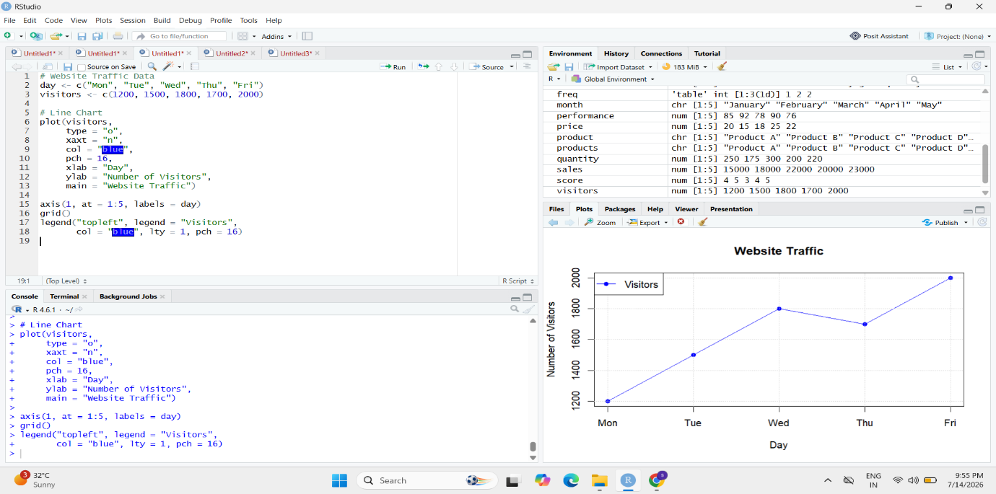
2. # Website Traffic Data
day <- c("2023-01-01", "2023-01-02", "2023-01-03",
"2023-01-04", "2023-01-05")

ctr <- c(2.3, 2.7, 2.0, 2.4, 2.6)

# Bar Chart
barplot(ctr,
names.arg = day,
col = "lightgreen",
xlab = "Date",
ylab = "Click-through Rate (%)",
main = "Top Click-through Rates")

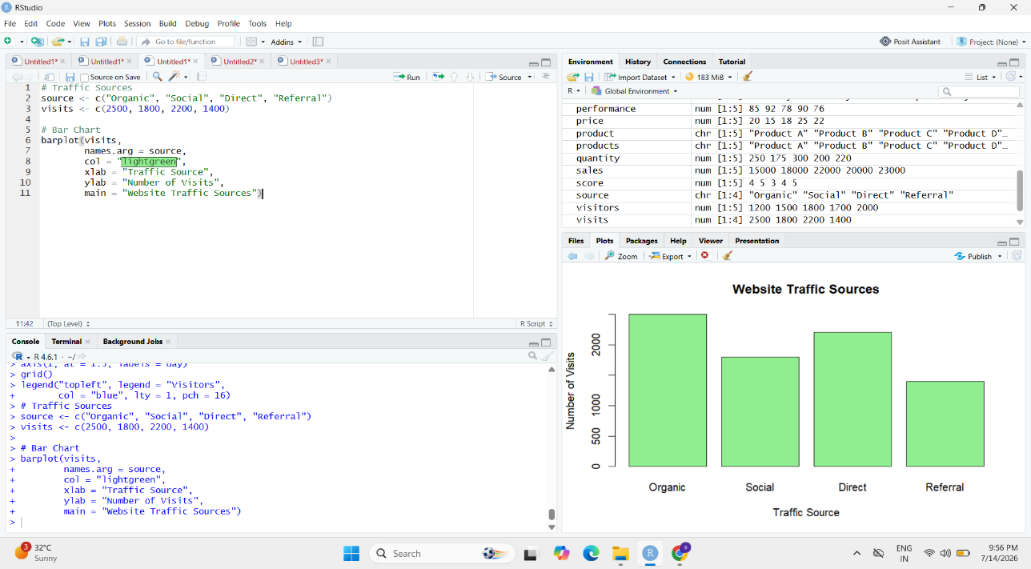

3. # Install package (Run once)
install.packages("ggplot2")

# Load package
library(ggplot2)

# Data
interaction <- data.frame(
Day = rep(c("Mon", "Tue", "Wed", "Thu", "Fri"), each = 3),
Type = rep(c("Likes", "Shares", "Comments"), 5),
Count = c(
200,100,50,
220,120,60,
250,140,70,
240,130,65,
280,150,80
)
)

# Stacked Area Chart
ggplot(interaction,
aes(x = Day,
y = Count,
fill = Type,
group = Type)) +
geom_area() +
labs(title = "Website User Interactions",
x = "Day",
y = "Count")

